​Part 1: October 1, 2014
In 2007, approximately 80% of Indiana local governments’ budgets were funded by property taxes. Today, property taxes fund just 39% of all local budgets (including public schools) and 60% of all municipal budgets.
A complex mixture of property tax caps and other factors affecting Indiana’s property tax system caused that change. Propelled by a 1998 Indiana Supreme Court mandate to change the way real property was assessed for tax purposes, the Indiana General Assembly not only changed how property is valued, they enacted multiple ways to provide their constituents with relief from property taxes.
They also gave local governments additional options for replacing the revenue – including Local Option Income Taxes (LOIT).
When these major changes were enacted, legislators and others used a set of assumptions and financial projections about how this would all work out.
It’s very much like the TV network sports commentators at the beginning of a football game. They will project that based on past performance, one team might be favored over the other. Of course, that assumes the favored team will be at its peak, the underdog will perform as they have in the past, no one gets injured, the weather cooperates and the rules of the game don’t change. But it is the score at the end of the game that tells the true story.
Umbaugh and Policy Analytics recently completed a study for the Indiana Association of Cities and Towns to analyze trends over the past eight years regarding revenue and budgets for local governmental units and schools.
How are the changes in the revenue mix affecting local governments? Our assumption has always been that the changes would affect different localities in different ways, but do the numbers confirm those assumptions? Even if the impact varies, do we see trends? And what remedies could be recommended to assure local governments continue to have the ability to provide needed services to their citizens?
Over the next few issues of Vision, we’ll detail the study results that were shared with IACT members in September. Here are three findings for you to think about until the next issue:
1. All 92 counties have adopted LOITs to fund local budgets, capital projects or property tax relief.
2. The losses property tax caps are much greater than projected in 2007.
3. Urban areas tend to lose the highest amounts to property tax caps (some up to 50%), and the losses are expected to continue growing.
In future installments, we’ll explain more about “why,” “how much,” and the trends and remedies identified in the study.
---

Part 2: January 8, 2015
The change in local government funding didn’t happen overnight, and we can’t solve every challenge immediately, so this series will take some time to examine:
1. How did we get here?
2. How have local governments been affected?
3. What do these changes mean for the future?, and
4. What options can we explore to adapt to these changes?
In the first overview article, we cited the 1998 Indiana Supreme Court mandate to change how real property was assessed for tax purposes as a major factor causing the transition away from property tax funding. Some of the inequity issues in local government finance, however, actually date back to 1974 when Governor Otis Bowen initiated a property tax freeze.
As you might imagine, the property tax freeze was highly popular, and Hoosiers appreciated the tax break. It kept property taxes at the same rate for a number of years. The freeze lead to state enacted levy controls we have today, limiting the percentage of increase in property taxes from one year to the next.
Of course, no one in local governments anticipated a freeze or levy controls when they adopted their budgets in the year before the freeze. If you were frugal and had low tax rates, that’s where your rates stayed, and that was your starting point when levy controls went into effect.
If you had a higher tax rate when the freeze was enacted, that higher rate became your baseline for the levy controls.
So the “haves” were able to get more, and the “have nots” had less. There wasn’t a level playing field when levy controls started.
In a future issue, we’ll explore more of how we got here starting with the relatively recent history of 2003 to 2014.
---

Part 3: March 17, 2015: How We Got Here
Our last article explained how the 1974 property tax freeze still affects the property tax rates we have today. (Click hereto read part one in the series or click here to read part two.)
Let’s fast forward to the last 12 years, when Indiana transitioned to a market value assessment, made various reforms to property taxes and introduced property tax caps.
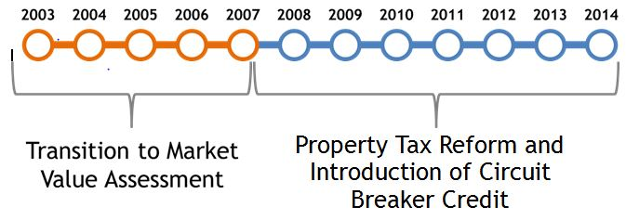
Here’s a quick overview of a vast change in the property tax system just during the first five years (the orange section of the chart):
- All real property was reassessed (due to the 1998 Indiana Supreme Court ruling that the replacement cost method was unconstitutional) using 1999 market values for taxes payable in 2003. (2003)
- The Homestead deduction was increased to $35K (2003)
- Counties were given the option to remove inventory from the tax base (required by 2007). (2004)
- Banked levies were eliminated, removing an option for units to accumulate reserve funding. (2004)
- Property tax rate caps or “circuit breakers” were introduced for the first time - to begin in 2008. As proposed then, rates would be capped at 2% for homesteads, and 3% for all other properties, when fully implemented. (2006)
- In what we call the property tax “crisis” statewide trending resulted in significant property tax increases for residential taxpayers. (2007)
- Inventories were fully exempted from the tax base (approximately 4.7% of Net Assessed Valuation or NAV) (2007)
- Limits were placed on State property tax relief. (2007)
- The General Assembly issued a one-time homestead rebate to offset property tax increases. (2007)
- Maximum levy banking was re-introduced, but at a 50% level. (2007)
- The Standard Deduction increased to $45K (3.5% of NAV) (2007)

What contributed to the 2007 property tax crisis?
Six years’ worth of market value changes (some due to the housing “bubble”) was incorporated into assessed values in a single year. Depending on where you are, the change in average Homestead Gross AV could be dramatic:
City | % change in Homestead AV 2005-06 to 2006-07
Fort Wayne | 29%
Goshen | 14%
Hammond | 14%
Crawfordsville | 22%
Shelbyville | 14%
Lawrence | 19%
It would be easy to blame increased local spending as the main cause of the tax increases, but that’s not what happened. In Marion County a combination of four different factors caused the average homestead property tax bill to increase by 24% from 2006 to 2007:
Elimination of Inventory Assessments | 4%
Cap on State Property Tax Relief | 4%
General Reassessment & Trending | 10%
Increase in Local Spending | 6%
In our next installment, we’ll summarize the changes that happened in the “blue” years on the chart from 2008 to 2014.
---

Part 4: May 13, 2015: How we got here
Our last article explained the vast changes that affected Indiana property taxes during the transition to a market value assessment system from 2003 to 2007. (Click here to read the series to date.)
This article will summarize the changes that happened in the “blue” years on the chart below from 2008 to 2014 as Indiana made various reforms to property taxes and introduced property tax caps.
- HEA 1001-2008 created the 1%, 2%, 3% circuit breaker credit and made other property tax changes described below. (2008)
- Introduction of the Supplemental Standard Deduction in statute. (2008)
- An additional one-year $620M, State-funded Homestead Credit was introduced to provide tax relief in 2008. (2008)
- State assumes responsibility for funding school general fund and county welfare. (2009).
- Circuit breaker credits are phased in, to be fully implemented in 2010. (2009)
- Supplemental Standard Deduction results in a 14% reduction in the statewide property tax base. (2009)
- Circuit Breaker caps are fully implemented at 1%, 2% and 3% of Gross AV. (2010)
- Due to a general reassessment, taxes payable in 2013 reflected the effects of the 2007-2010 national recession. (2013)
- The general reassessment and national recession also caused significant reductions in the value of commercial and industrial property. (2013)
- Business Personal Property Tax legislation gives counties the option to exempt small returns (<$20K) and to exempt new personal property beginning with taxes payable in 2017. (2014)
- The same Business Personal Property Tax Legislation enhanced personal property abatement to 20 years. (2014)
HEA 101 in 2008 did more than enact the tax caps; it significantly altered State funding of local units by eliminating the Property Tax Replacement Credit, phasing out the Homestead Credit and shifting the school general fund, county welfare, and public safety pension responsibilities to the State. It introduced the Supplemental Standard Deduction, increased Standard Deduction to 60% of Gross AV (up to $45K), increased the state sales tax rate and added a referendum requirement for large capital projects.
Now that you have a basic understanding of how these changes in funding occurred, the next installment will begin to explain what the changes mean for local governments.
---

Part 5: June 18, 2015: What the changes mean for local governments
What does it mean for homeowners?
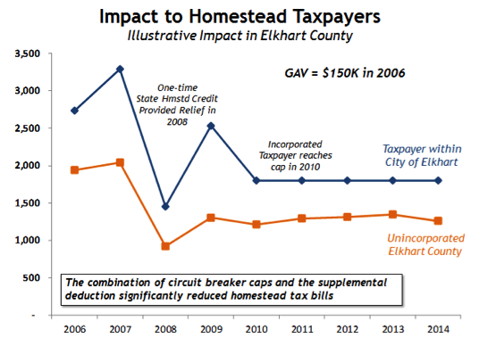
Homeowners, in general, pay less in property taxes than they did before – and that usually makes them happy. The amount of the reduction depends on where you live. This example from Elkhart County shows the level of property taxes in 2006, an upward spike with reassessment in 2007, a downward spike in 2008 due to the one-time Homestead Credit to provide property tax relief and a leveling out starting in 2010 when the property tax caps were fully implemented. If you were in the unincorporated part of Elkhart County, your property tax rates started and ended lower because you receive fewer services than city properties, but the tax amounts followed the same general pattern.
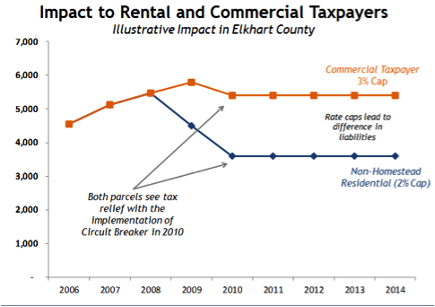
What does it mean for rental properties and commercial taxpayers?
As you might expect, this chart shows that although both rental and commercial properties in Elkhart County pay less after the property tax caps were in place in 2010, the reduction for rental properties (2% cap) was greater than it was for commercial properties (3% cap).
What does it mean for local governments?
While taxpayers are happy to pay less, the story for local governments is quite different. The loss of revenue for local governments is $800 million – or 60% greater than the Legislative Services Agency projected when the tax caps were enacted.
Indiana’s property tax caps are different from others in two important aspects:
1. Indiana’s circuit breaker tax caps limits the total tax rate and not the rates of individual taxing units (so all taxing units are now in a competition for their share of the total)
2. Revenue losses from the tax cap are not funded – other states that enacted tax caps also created a way to fund the loss.
Seventeen cents of every dollar levied in Indiana is not collected due to the tax caps.

---

Part 6: July 7, 2015: The effect on local governments
It is a basic truth that property tax rates are higher in incorporated areas than they are in unincorporated areas. That’s because cities and towns provide more services, such as sewers, water, police and fire protection, parks, trash collection and snow removal.
Thus, the higher tax rates in incorporated areas are more likely to hit the property tax caps, providing relief to the taxpayer, but reducing income for services. If you are in an unincorporated area, you are much less likely to experience the benefit or the loss (depending on your perspective) of Indiana’s tax caps.
This chart for Tipton County shows that cities and towns have tax rates that will hit the tax cap. The incorporated parts of the townships are unaffected.
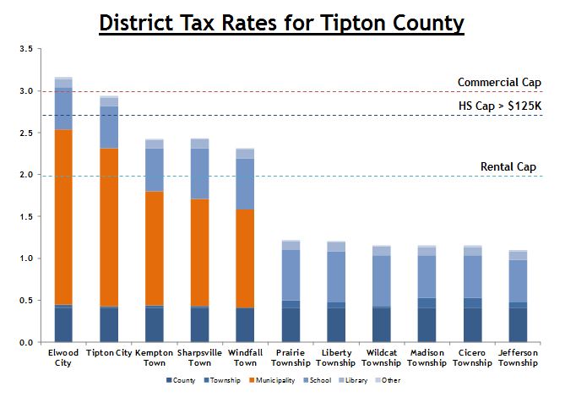
Here’s what the loss of certified levy looks like statewide: in general, the greatest losses in revenue are concentrated in cities. The 25 municipalities with the highest tax cap impact have losses ranging from 25% to 50% of their levies; the average for these 25 municipalities grew to 30% by 2013 .
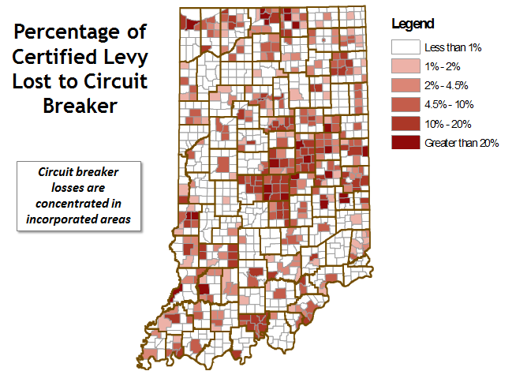
---

Part 7: July 22, 2015: The effect on local governments
The amount of revenue a local government receives from property taxes is a function of the tax rate and the assessed value of the properties being taxed, with an adjustment for the impact of the property tax caps.
Indiana’s assessed values of real property were impacted by the national recession that began in 2009, causing values to stagnate, rather than grow as had been projected by the state. Most of the growth that did occur was in personal property and agricultural land, which is assessed using a productivity factor.
 | Increase 2007-2014 | Avg. increase per year
Gross Assessed Value(indexed to 2007) | 6.1% | 0.9%
GAV personal property | 17.9% | 2.4%
GAV real property | 5.1% | 0.7%
GAV non-agricultural property | 2%
The chart below shows the impact of the change in gross assessed value statewide. You’ll notice that the greatest losses in GAV align almost perfectly with the chart from our last article showing that the losses in revenue concentrated in cities.
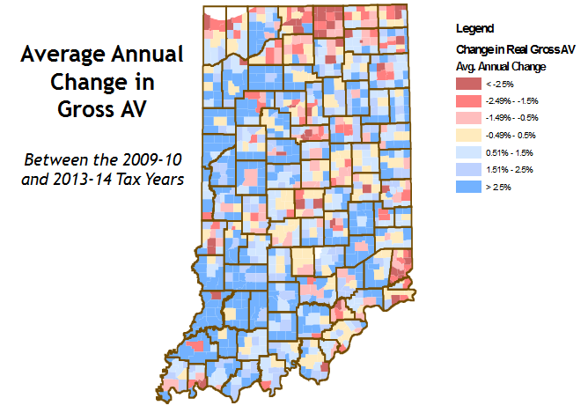

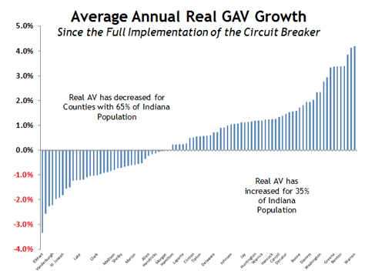
Although it is true that the majority of Indiana’s counties saw growth in gross assessed value, those counties are home to just 35% of Indiana’s population. The counties where 65% of our population lives experienced a decrease in GAV, which affects their ability to generate revenue.
---
Part 8: August 18, 2015: The effect on local governments
When the tax rate in your area is above the property tax caps, local governments reach a point where levying more in your tax rate doesn’t result in collecting the full amount of the tax increase. The additional revenue to fund the levy increase either has to come from:
• taxpayers still below the tax cap or
• other units of government.
Let’s use the example of a coffee shop with an assessed value of $100,000. The municipality’s total tax rate is $3.35. The coffee shop, which as a commercial property at the 3% tax cap, pays a maximum of $3,000 a year in property taxes.
Let’s say the school district gets a levy increase of 20 cents.
Unit Type | Rate |  | Unit Type | Rate
County | 0.5000 |  | County | 0.5000
Township | 0.1000 |  | Township | 0.1000
Municipality | 1.5000 |  | Municipality | 1.5000
School | 1.0000 |  | School | 1.2000
Library | 0.2500 |  | Library | 0.2500
District Rate | 3.3500 |  | District Rate | 3.5500

The coffee shop owner is OK with that, because she’s still paying a maximum of $3,000.
The school gets more revenue, but still not the full amount of its levy. The additional revenue for the school district from the coffee shop’s $3,000 tax payment is coming at the expense of the library, county, township and city.
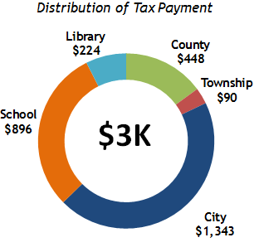 | 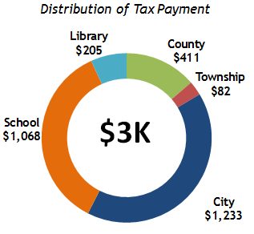
Our analysis showed that if the City of Fort Wayne levied an additional dollar in property taxes, it would produce only 60 cents in revenue for the City – and 40 cents of that 60 would come out of distributions for other taxing units. The additional dollar in levy would generate just 20 cents of new revenue.
What can local governments do to meet growing expenses? We’ll cover that in future installments of this series.

