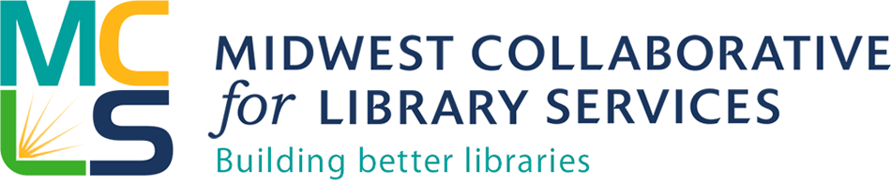

MCLS Indiana Grant Initiative

Project: $500 collection development mini-grants for School Libraries

Deadline: Midnight, December 30, 2015

Applicant institution must be a member of MCLS. Only one application per school district will be accepted. Awards will be based on need. Submit completed application by email to Michelle Bradley, MCLS Community Engagement Librarian at bradleym@mcls.org

Information about your school district and library
- Name of school district
- Address
- MCLS Member?
- Percentage of students in school district eligible for reduced or free lunch
- Annual materials budget
- Number of full time students

Statement of Need
Describe why your library is in need of the grant funds and how you plan to spend the funds (in one page or less.)

Authorization

Authorizing School District Official Information
- Authorizing Official First Name
- Authorizing Official Last Name
- Email Address
- Phone Number
- Title
- School District
- Certification—By checking this box and submitting this application, the authorized representative for the applicant organization certifies that all statements contained herein are true and correct to the best of their knowledge and belief. _____________
- By checking this box and submitting this application, the authorized representative for the applicant organization certifies that if awarded funds, the funds will be used exclusively for the purposes stated in the grant announcement.

Awards will be announced, and grant checks distributed by January 15, 2016.

