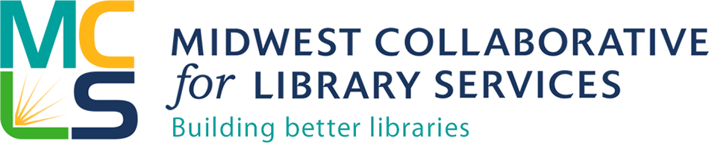

MCLS Indiana Grant Application

Project: Scholarship to attend the Harwood/ALA Public Innovators Lab for Libraries in Detroit, MI October 14-16

Deadline: Midnight, July 31, 2015

Submit completed application by email to Michelle Bradley, MCLS Community Engagement Library at bradleym@mcls.org

Information about your library
- Name of Library
- Address
- Library Type (Public, Academic, School, Special, Institutional)
- MCLS Member?
- Population Served
- Website

Name, title, email and phone number of person(s) on your staff who is seeking the scholarship (MCLS will fund a maximum of 2 people per library system)

Narrative

- How will you define your community? (local community, campus, school, etc.) Describe your community including geography, socio-economic characteristics, ethno cultural make up, and other relevant information.
- Describe where your library is at in relation to community engagement, what you hope to achieve as a next step, and how being involved in this project will help you and your community.
- Describe the extent that your library is involved in formal partnerships and networking in your community, providing specific examples.
- Describe the top innovation that your library has led/implemented in the past two years.
- Describe why this opportunity interests you and your library. Include specific opportunities or challenges that you hope to address through this community engagement work, and the specific site, branch or location where you intend to base the work.
- Have you or other members of your library participated in any learning sessions or training in the Harwood Institute approach? If so, please detail your experience.

Authorization

Authorizing Official Information
- Authorizing Official First Name
- Authorizing Official Last Name
- Email Address
- Phone Number
- Title
- Organization
- Certification—By checking this box and submitting this application, the authorized representative for the applicant organization certifies that all statements contained herein are true and correct to the best of their knowledge and belief. _____________
- By checking this box and submitting this application, the authorized representative for the applicant organization certifies that if awarded funds, the funds will be used exclusively for the purposes stated in the scholarship announcement. If awarded the funds and unable to attend the Lab, funds will be returned to MCLS. _______________

